
This is to certify that


Has successfully completed instruction and has demonstrated the knowledge and competencies to receive the following

TEMPORARY CERTIFICATE

INTERNATIONAL WATCHKEEPER/FLOTILLA SKIPPER SAIL

and is being issued this temporary certificate valid for 6 weeks from date of issue by Aquatoria Training Center

.

while the final certificate is being generated by IYT Worldwide
Temporary Certificate Number

Partner School Principal or Instructor Signature
Partner School Principal or Instructor Printed Name

This course was completed with
Aquatoria Training Center
Moscow region, 142304, Chekhovian area, village Bolshoe Petrovskoe Yasenevaya Street,54.

Aguatoria-FSS-00003
Date of Course Conclusion


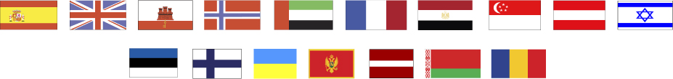
International Yacht Training Worldwide
Suite 482; 9-3151 Lakeshore Rd
Kelowna, B.C V1W 3S9; Canada
www.IYTworld.com; info@IYTworld.com

Date of Birth: _________________

Date of Issue: _________________

